1.INTRODUCTION

1.1 Overview

E-commerce is the most popular method of exchanging products and services. Nowadays, an increasing number of individuals choose to purchase publications over the internet and other aided technologies. Social media, advancements in e-commerce app development, growing demand for mobile shopping, and other digital modalities are key elements driving this e-commerce revolution.

The grocery market in India has evolved considerably in the past decade. Here’s what you need to know about the changing face of demand, dynamics and disruption in the sector, and the implications for retailers and consumer-packaged-goods players alike.

* *“Innovation for India”:*A connected India has led to the birth of start-ups, which have built or adapted their operating models to the local context.
* *Emergence of ecosystems:*[Direct-to-consumer](https://www.mckinsey.com/capabilities/growth-marketing-and-sales/our-insights/dtc-e-commerce-how-consumer-brands-can-get-it-right) ecosystems have become a market-shifting force .

1.2 Purpose

**Definition**

The definition of "grocery store" varies; U.S. and Canadian official definitions of "grocery store" exclude some businesses that sell groceries, such as convenience stores.

**Early history**

Beginning as early as the 14th century, a grocer (or "purveyor") was a dealer in comestible [dry goods](https://en.wikipedia.org/wiki/Dry_goods) such as [spices](https://en.wikipedia.org/wiki/Spices), [peppers](https://en.wikipedia.org/wiki/Bell_pepper), [sugar](https://en.wikipedia.org/wiki/Sugarloaf), and (later) [cocoa](https://en.wikipedia.org/wiki/Cocoa_solids), [tea](https://en.wikipedia.org/wiki/Tea), and [coffee](https://en.wikipedia.org/wiki/Coffee). Because these items were often bought in bulk, they were named after the French word for wholesaler, or "grossier". This, in turn, is derived from the Medieval Latin term "grossarius",[[8]](https://en.wikipedia.org/wiki/Grocery_store#cite_note-8) from which the term "gross" (meaning a quantity of 12 dozen, or 144) is also derived.

From the late 1600s until the 1850s, the word "grocery" referred to a [place where people went to drink](https://en.wikipedia.org/wiki/Bar_(establishment)).[[9]](https://en.wikipedia.org/wiki/Grocery_store#cite_note-9)

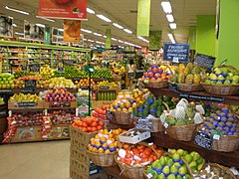

2.LITERATURE SURVEY

**2.1Existing Survey**

In today’s society, we have entered the era of information technology, which is not only an objective factor of economic development but also our common recognition and judgment of the characteristics of the times we live in. The reason why we think this is the information age is that information has a far-reaching impact on the economic and social life of each of us and has caught up with the influence and change of the natural geographical environment and social interpersonal interaction

The cost of products is increasing, and ultimately, the price of products is increasing. On the contrary, in the process of delivery, transportation, distribution, and inventory of products sold online, the cost of management is much lower than that of physical stores. Therefore, the prices of some products on the Internet will be relatively preferential. At the same time, enterprises can communicate with upstream and downstream platforms in a convenient and fast way by launching e-commerce. Specific implementation measures, especially the use of BDT, e-commerce network marketing for innovation and development research is relatively small.

2.2 Proposed Solution

The key to unlocking budget lies in being able to prove the ROI of your marketing efforts. According to our report, organizations that can calculate ROI are 1.6 times as likely to receive higher budgets. Again, success with inbound marketing also plays a large role in driving higher budgets. Effective strategies obviously produce results, and our data shows those who feel confident in their marketing strategy are over 2 times as likely to get higher budgets for their marketing teams.

### Be transparent

Being honest as well as [transparent about what customers can expect](https://www.mageplaza.com/blog/win-customers-give-transparency-they-love.html) from your company from your brand from the very first interaction is one of the most vital elements to keep customers stay with you in the long term. The information about your contact, credibility badges, pricing, any policies, customer reviews, and testimonials, etc. should be displayed clearly on your website.

### Customer Loyalty

Establishing a solid base of [long term relationship with customers](https://www.mageplaza.com/blog/excellent-ideas-loyalty-programs.html) is essential for building a successful business. It is shown by the fact that customer retention is much more cost-effective than constant acquisition as it **costs five times more to convert a new customer** than it does to keep an existing one. Furthermore, [83%](https://www.invespcro.com/blog/customer-acquisition-retention/)of them say that they do not hesitate to recommend a business they trust to others. The success rate of selling to a current client is 3 -4 times higher compared to that of a new one.

3.Theoritical Analysis

3.1 Block Diagram

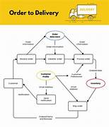

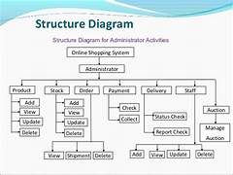

3.2 Hardware/Software Designing

**Hardware:**

For this we had used the operators like laptop, mouse, keyboard and etc.

**Software:**

We had used the software applications like the languages HTML, CSS, JavaScript**.**

We learnt the languages for a 30 days with the help of APSCHE team.

They had guided us a mentor Shivani Kapoor Madam. We thankful to mam.

**Result**

**Over the past 24 months,** e-commerce in the North American grocery industry has continued to mature and scale. The pandemic accelerator for grocery e-commerce, with much of the sector experiencing the equivalentof more than [five years of growth in just five months](https://www.mckinsey.com/industries/retail/how-we-help-clients/the-state-of-grocery-retail-2021-north-america).

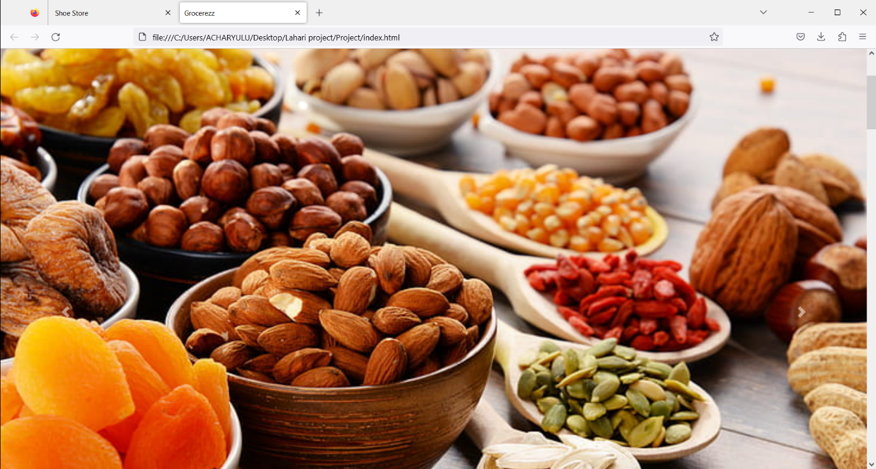

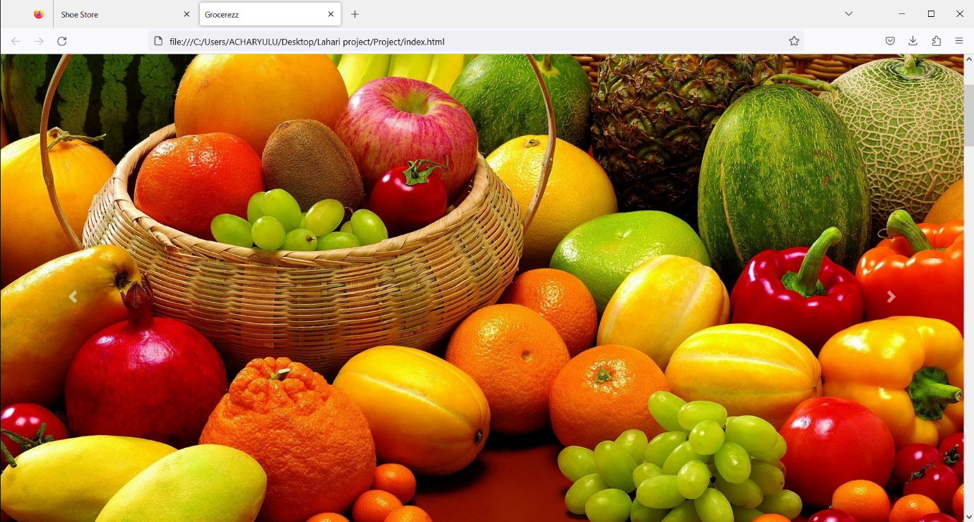

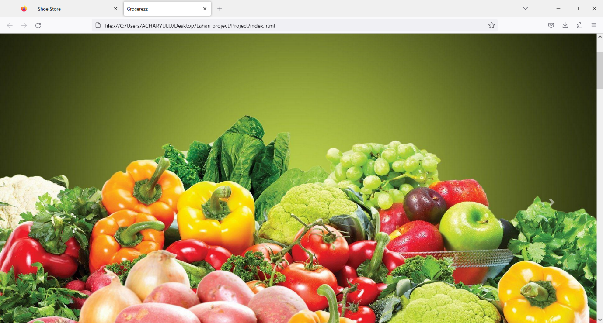

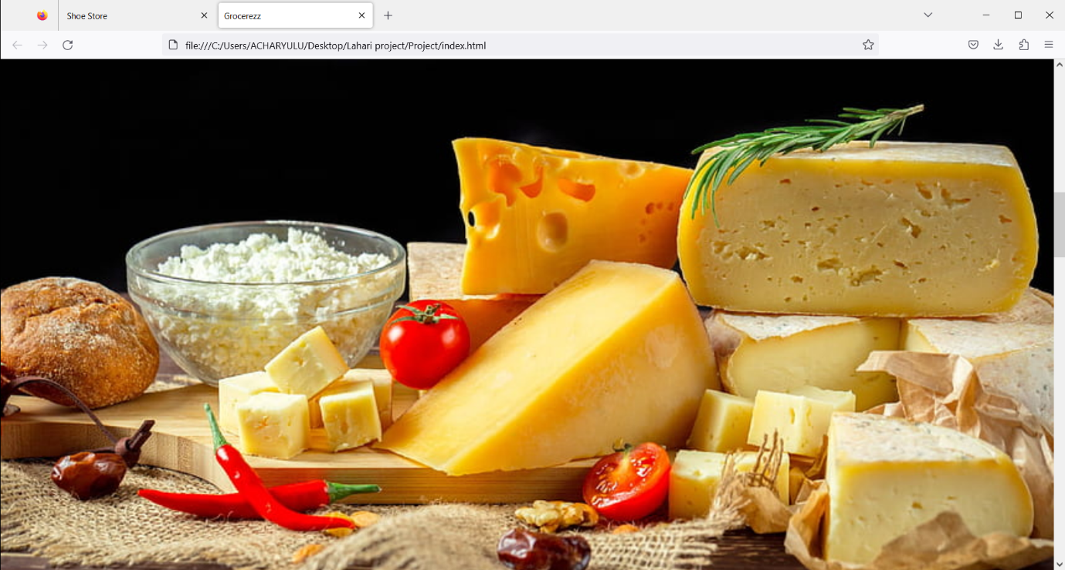

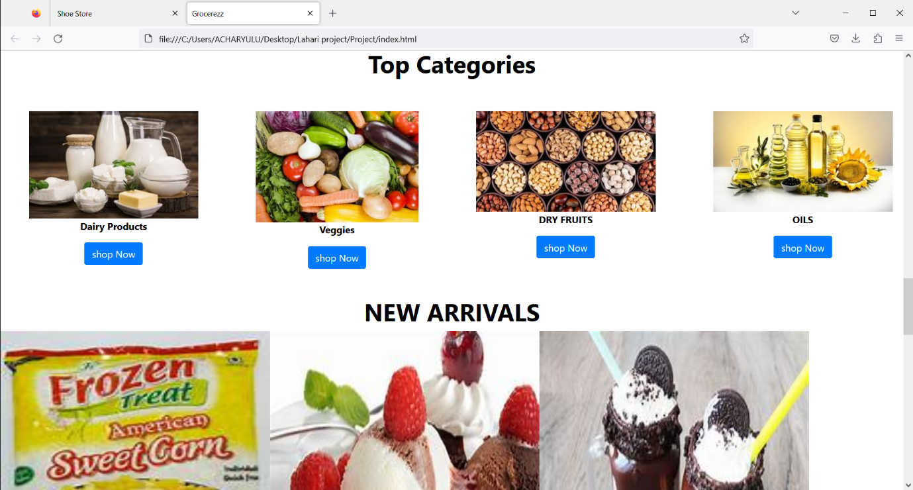

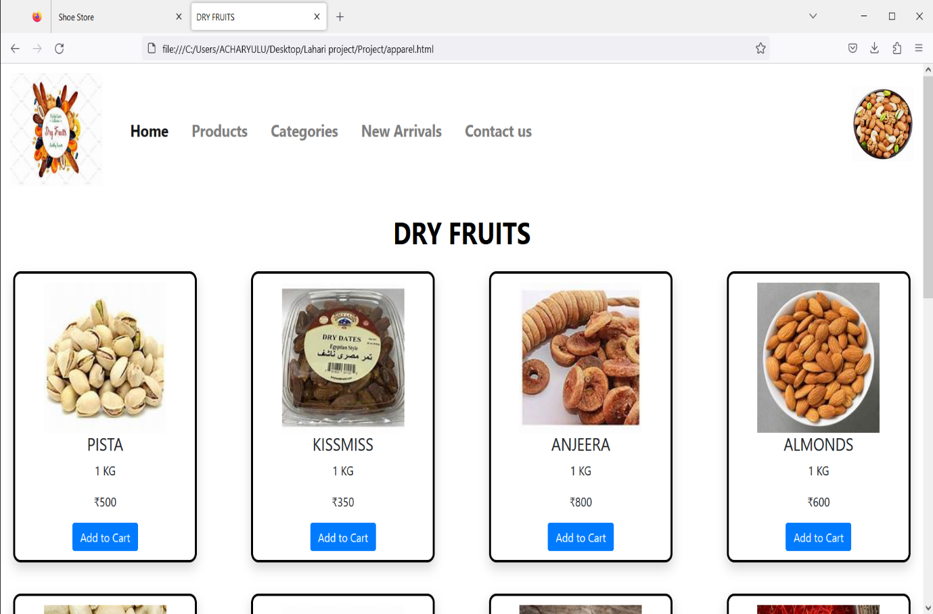

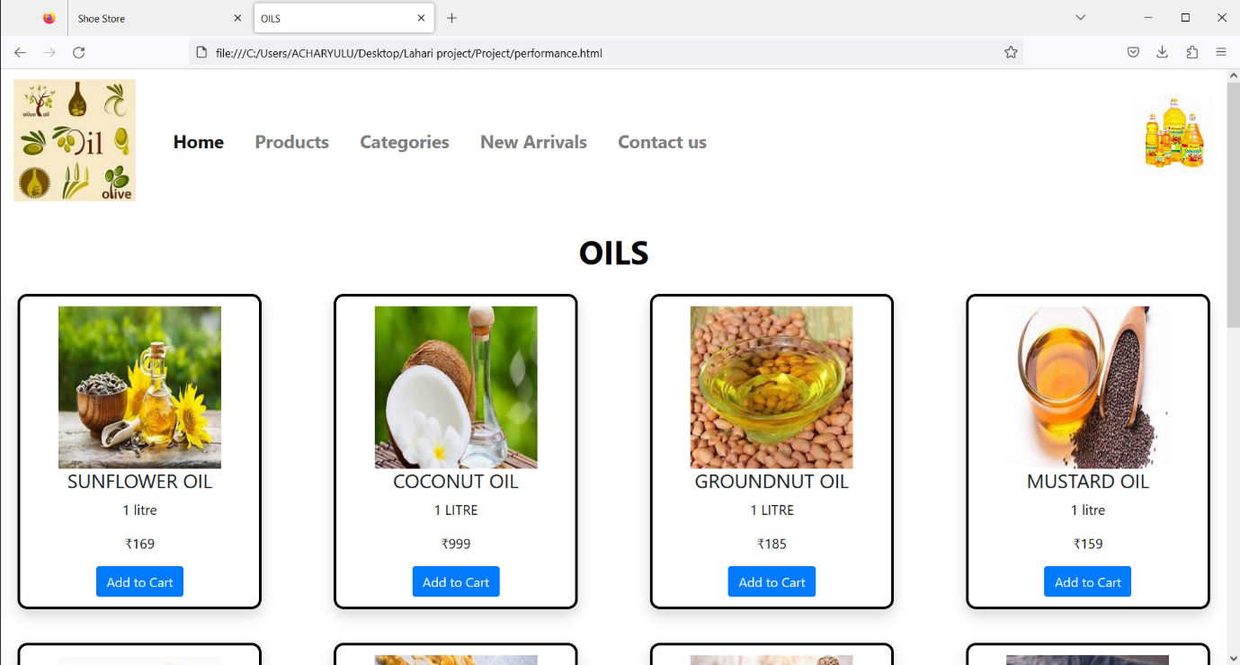

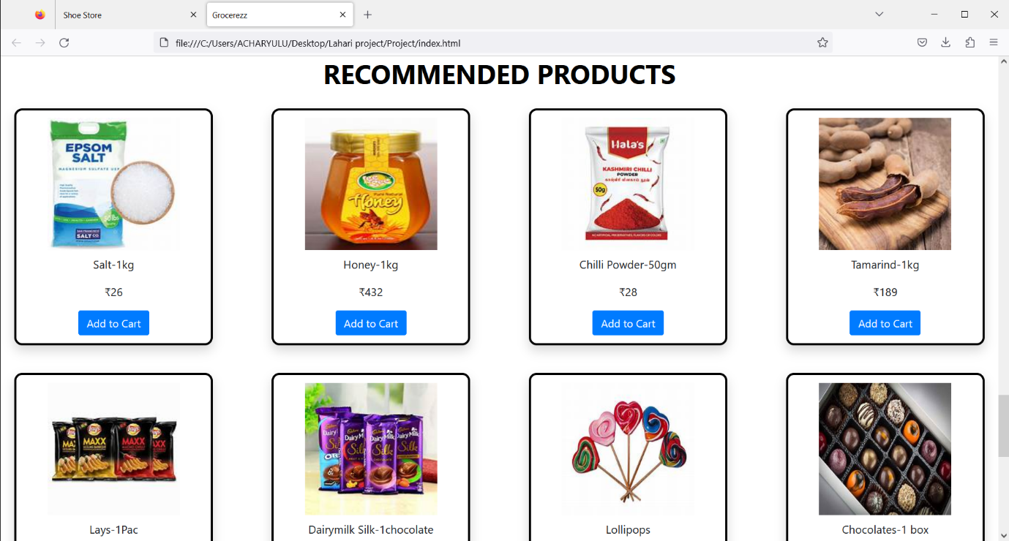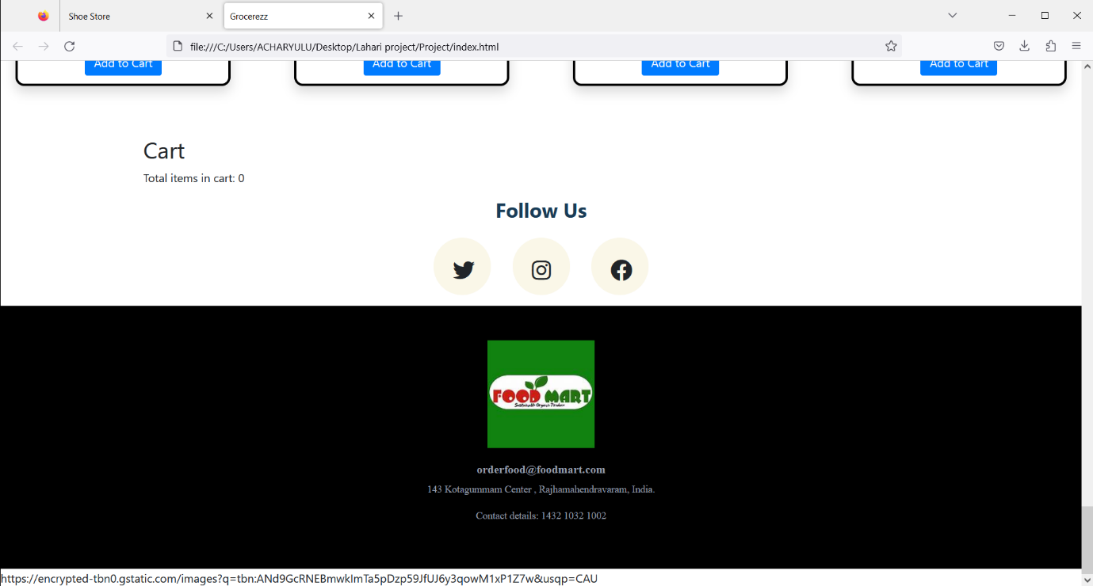

**Advantages & Disadvantages**

Advantages:

Loyalty involves accepting and loving someone for who they are, and not [threatening to leave](https://www.verywellmind.com/threatening-divorce-during-an-argument-4088210) them when things become challenging. People display loyalty by weathering storms together, providing support, and sticking it out.

[**Being transparent is more than good policy**](https://changinghighered.com/college-and-university-closures-transparency/). It’s a way of ensuring your employees stay satisfied.  You trust them with the information and in turn, they reward you with loyalty. Organizational transparency creates trust among stakeholders, informs decision-making, and fosters greater participation.

Disadvantages:

It can be hard for someone who is loyal to recognize when they are being [manipulated](https://www.verywellmind.com/manipulation-in-marriage-2302245) by someone they love. It can be helpful to get an outside perspective from a friend, family member, colleague, or therapist who has their best interests at heart.

* Understanding the risk that information may be distorted, misunderstood, or misrepresented
* Being aware that organizations that practice full transparency may be open to attack, vulnerable to those groups that feel underrepresented or alienated

Applications

E-commerce applications is a somewhat confusing terminology since it may lead to two different interpretations: one that refers to the use of e-commerce as a marketing medium; retail and wholesale; auctioning; e-banking; booking, and so on.

**E-commerce applications** is a slightly confusing phrase since it leads to two different perceptions: one where it refers to the use of e-commerce as a medium of marketing; retail and wholesale; auctioning; e-banking; booking, and so on.

The second concept that comes to mind is a software program like Amazon, eBay, Groupon, etc. It might be a web application or [**applications of e-commerce**](https://lilacinfotech.com/what-we-do/retail-e-commerce-app-development) (now popularly known as m-commerce applications). **Mobile e-commerce applications** are just an extension of e-commerce. Mobile app concepts are the driving force behind any successful business app, a [**food delivery app**](https://lilacinfotech.com/what-we-do/food-delivery-on-demand-app-development-india)**.**

**1. Digital Shopping**

People's buying habits have shifted dramatically in the previous several years. "Go online" has become a success mantra for all enterprises. [Online shopping](https://lilacinfotech.com/blog/84/20-Best-Online-Shopping-Apps-in-India-for-2021) is easy, pleasant, and, in most cases, inexpensive. The success of online shopping applications like **Flipkart and Amazon** demonstrates this.

**2. Web and mobile applications**

Mobile commerce or **m-commerce application** is a subset of retail e-commerce. [**Mobile or web application development**](https://lilacinfotech.com/)has become a must-have for companies looking to showcase their skills. Purchases are made by the consumer using mobile or web applications that are optimized for the merchant. These programs also provide payment security by utilizing secure e-payment mechanisms.

**3. Internet Banking**

E-Banking, often known as online banking, is an **e-commerce program** that has streamlined people's time-consuming and complex banking operations. It allows bank customers to do transactions online without having to wait in lengthy lines at banks. To provide virtual banking services to their consumers, most of the banks now have their web applications.

CONCLUSION

E-commerce still represents one of the business methods that take advantage if done the right way, even if the stock market and commodities fell, but E-Commerce still able to survive and receive high transaction. E-commerce has a tremendous opportunity in the course of or business in Malaysia. In addition, it is also to introducing new techniques and styles in a transaction. Use the extensive E-Commerce in the Internet world is actually much better to bring the goodness of the individual or the state.

The online grocery market in India has gained a lot of traction over the past few months with the emergence of a host of first-generation start-ups and already established traditional grocery chains expanding to the digital platform. India's online grocery market is estimated to grow at a compounded annual growth rate of 62 per cent between 2016-2022. Also there are many online grocers coming up every week. Going by the way the global egrocers are growing and the growth of e-commerce in the Indian market, and online would capture a small but significant market share. Therefore, the rapid growth of organized and online players is going to make their prominence in the next decade.

**FUTURE SCOPE**

**1. The E-commerce Experience will Transcend The Screen.** In addition to delivering an experience through all screen types, future experiences will be delivered through new touchpoints such as voice, wearables and kiosks. For example, Staples now has AI-powered product search on touch-screen kiosks in their stores.

**2. The E-commerce Experience will be More Personalized.** While this has been a buzzword for decades, the next wave of personalization will do a much better job of predicting needs. Each individual will get a different experience based on geography, searching history, past behavior, etc.

**3.** **The E-commerce Experience will Include a Lot More Relevant Content.** Consumers want brands that have values and convey the values in a personalized way to the shopper. This requires content. E-commerce brands are moving toward the creation of more, relevant, and helpful content that drives engagement and facilitates the right purchase. Machines will enable this occur faster for long-tail retail items, in real time, allowing humans to develop the biggest experience-enhancing content.